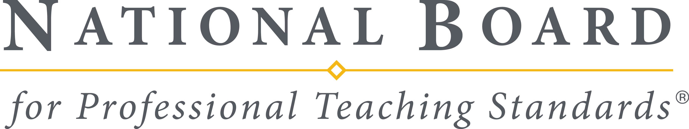

Mail to: National Board for Professional Teaching Standards
Attention: Corporate Affairs
1525 Wilson Blvd., Suite 700
Arlington, VA 22209
Phone: 703-465-2700 Fax: 703-465-2715

REQUEST from NBCT or Veteran Candidate to use Personal Copy of
ASSESSMENT PERFORMANCE(S)

The National Board Policy for Use of NBCT and Veteran Candidate Assessment Performances is to restrict use by NBCTs and veteran candidates (those who have applied but never achieved) of their responses (including video recordings, written commentary sheets, instructional materials, essays, classroom plans, assignments, and comments and, as applicable, student work). As part of the application and assessment process, candidates assign to NBPTS all of their copyright and other intellectual property rights (including rights of publicity) in the responses and authorize broad use by NBPTS, its agents, contractors, designees and licensees, of the responses, as described in the candidate, student and adult releases.

In keeping with the policy, the following provisions shall prevail:
- NBPTS prohibits NBCTs from making commercial use of their responses.
- NBPTS grants permission to all NBCTs and veteran candidates the right to use their personal copies of portfolio responses for personal, non-public, nonprofit, educational purposes consistent with NBPTS' ethics guidelines.
- NBCTs are required to obtain NBPTS’s permission to use their personal copies of portfolio responses for any purpose other than personal, non-public, nonprofit, educational use.
- NBCTs are prohibited from assigning or licensing the right-of-use of their personal copies of portfolio responses to another.

To request permission to use NBPTS assessment performances, provide the following information as specifically and completely as possible. Please type or print responses.

Permission requested by:
NBCT Veteran Candidate Contractor Staff
Name: Date:

Organization

Address:

City/state/zip:

Phone Number:

Fax Number:

Email:

- Provide a description of the assessment performance(s) you wish to use.

- Explain the purpose for which you plan to use the assessment performance(s) and the intended audience.

3. What fee, if any, will be charged for viewing the assessment performance(s)?

- For what period of time will the assessment performance(s) be used?

- During this period of time, how many times will the assessment performances(s) be used?

I hereby designate acceptance of and agreement with the following terms of permission.
- NBPTS prohibits NBCTs from making commercial use of their responses.
- NBPTS grants permission to all NBCTs and veteran candidates the right to use their personal copies of portfolio responses for personal, non-public, nonprofit, educational purposes consistent with NBPTS' ethics guidelines.
- NBCTs are required to obtain NBPTS’s permission to use their personal copies of portfolio responses for any purpose other than personal, non-public, nonprofit, educational use.
- NBCTs are prohibited from assigning or licensing the right-of-use of their personal copies of portfolio responses to another.

_________________________________________
Printed Name

__________________________________________ ________________________
Signature Date

Below for NBPTS use only

Approved in accordance with NBPTS policies and guidelines and with the understanding that full credit will be given to the source.

APPROVED BY:

National Board for Professional Teaching Standards

_____________________________________________ _______________________
Name Date
___________________________________________________________________
Title

