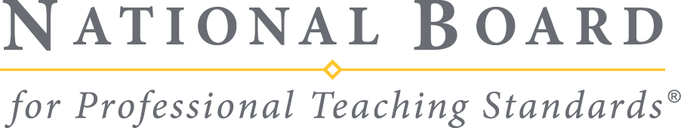

Acceptable State Licenses

Updated 06.03.2026

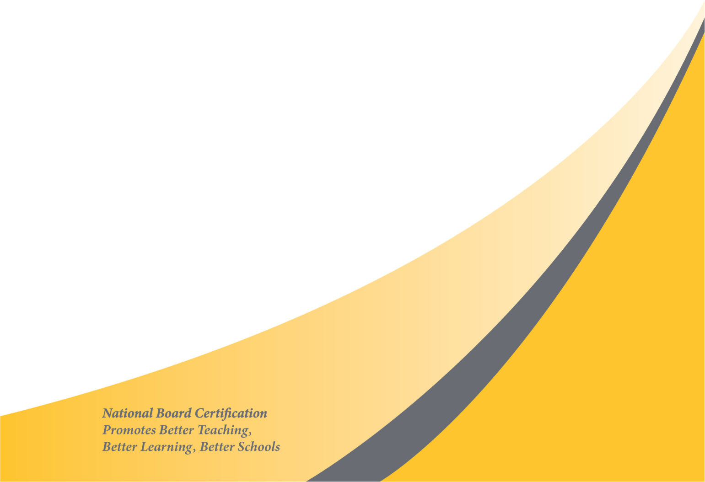
Prepared by Pearson for submission under contract with the National Board for Professional Teaching Standards®
© 2026 National Board for Professional Teaching Standards | All rights reserved.

Contents
This document is a listing of acceptable licenses listed by state.

Alternative and Emergency credentials not listed below are acceptable IF the potential candidate holds a license from the Acceptable Licenses column at the time of registration/component purchase.
Speech language pathologists often find a "fit" in the Early Childhood through Young Adulthood/Exceptional Needs Specialist (ECYA/ENS) certificate. If the potential candidate has a license from the state board of education allowing him/her to teach in the schools and meets the education and employment requirements, he/she is welcome to pursue certification.
For potential Early Childhood through Young Adulthood/School Counseling (ECYA/SC) candidates: The teaching credential must have a School Counseling or Guidance Counseling endorsement. A Social Work or School Social Work endorsement is not acceptable.
- NOTE: States regularly update their licenses and license requirements. If you do not see a particular license listed in this table or have other questions related to licenses that are acceptable for National Board Certification eligibility, contact our Customer Support team (using the National Board web form. Be sure to include a copy of the license(s) in question.

State | Acceptable Licenses | Time spent teaching under this license is acceptable ONLY IF the potential candidate holds a license from “Acceptable Licenses” column at the time of registration/component purchase. | Non-Acceptable Licenses
AL | - Professional Certificate (Class A/B)  - Career/Technical (CT) level 3 & 4
AK | - Initial  - Professional  - Master  - Teacher Certificates
AZ | - Standard Certificate  - Provisional  - Reciprocity Provisional  - Speech Language Technician & Standard Speech Language Impaired (Only if issued by the state DOE.)  - International Teaching Certificate | - Teaching Alternative Certificate | - Teaching Intern Certificate
AR | - Standard  - Initial  - Preliminary Credential  - Provisional | - One Year Provisional
CA | - Clear Standard  - Professional  - Single Subject Credential  - Level 1 Specialist Credential  - Level 1 and 2 Education Specialist Instruction Credential  - Speech Language Technician (Only if issued by the state DOE.)  - Preliminary Emergency Long Term  - District Intern Credential  - Clinical or Rehabilitative Services Credential |  | - Certificate of Clearance  - Emergency Permits (including the following):  - Provisional Internship Permit  - Short-Term Staff Permit  - Limited Assignments Permits in General and Special Education  - Crosscultural, Language and Academic Development (CLAD) Permit  - Bilingual Authorization Permit  - Teacher Librarian Services Permit  - Resource Specialist Permit  - Child Development Program Director Permit
CO | - Initial  - Provisional  - Professional License  - Standard Speech Language Impaired (Only if issued by the state DOE.) | - Temporary Teacher Eligibility | - Professional Special Service: School Psychologist  - Standard Speech Language Impaired
CT | - Initial  - Provisional  - Professional Educator Certificates |  | - Durational Shortage Area Permit
DE | - Standard  - Continuing  - Advanced
DC | - Initial  - Standard  - Professional  - Regular II A | - Provisional
FL | - Temporary  - Professional |  | - Broward Special  Florida CTE
GA | - Clear Renewable  - Non-Renewable
Guam | - Professional II
HI | - Professional  - Standard  - Advanced |  | - Emergency Hire Permits
ID | - Initial  - Standard |  | - Interim Education Certificate
IL | - Professional Certificate  - Initial  - Standard  - Master  - Provisional Certificate  - Provisional Secondary  School Service Personnel (For ECYA/SC)  - Provisional Vocational Certificate  - Initial Alternative Certificate | - Provisional Alternative | - IL Substitute  90 Day Teaching Sub. Certificate  - Transitional Bilingual
IN | - Professional  - Standard License  - Provisional  - Professional
IA | - Initial  - Standard  - Master Educator | - Conditional One Year
KS | - Initial  - Standard  - Conditional  - Professional  - Accomplished
KY | - Professional Certificate  - Provisional  - Standard  - Teacher Internship Statement of Eligibility  - Provisional Internship | - Temporary Provisional | - Conditional
LA | - Level 1-3 Teaching Certificate  - Type A, B, & C Certificates  - Out of State Certificate  - 1 yr. Practitioner's License  - Temporary Authority to Teach |  | - Ancillary
ME | - Initial
MD | - Initial Professional License  - Standard Professional License (SPC I & II)  - Professional License  Advanced  - Professional License  - Temporary Professional License  - Montessori Professional License | - Conditional License (CL)  - Conditional Special Education  - License (CSEL)  Resident Teacher License (RTL)
MA | - Initial  - Professional  - Preliminary  *Note: Initial certificates no longer contain an expiration date and are approved for processing. |  | - Waiver License
MI | - Standard Teaching Certificate  - Temporary Teaching Certificate  - Professional Teaching Certificate  - Advanced Professional Teaching Certificate  - School Counselor License  - Temporary School Counselor License  - The following licenses, while no longer issued, are acceptable if unexpired:  - 18-Hour Continuing Certificate  - 30-Hour Continuing Certificate  - Permanent Certificate  - Full Vocational Authorization |  | - Limited License to Instruct (LLI)  - Preliminary School Counselor License  - Interim Teaching Certificate
MN | - Standard  - Professional
MS | - SEL: Class A (Vocational, Alternate Route, and Interim)  - SEL: Class AA  - SEL: Class AAA | - SEL: Class A 1 Year Educator License
MO | - Initial Professional  - Lifetime  - Professional  - Continuing Certificates (PC I, II or CPC)  - Career CPC  - Provisional |  | - Temporary Authority  - Temporary
MT | - Educator License (Class 1 or 2)
NE | - Initial  - Standard  - Professional
NV | - Standard  - Professional  - Initial
NH | - Beginning Educator License  - Experienced Educator License |  | - Intern Authorization
NJ | - Standard (Permanent)  - Provisional  - NJ Certificate  - Certificate of Eligibility with Advanced Standing
NM | - Provisional Level 1  - Professional Level 2  - Professional Level 3  - Limited Level One Extension  - Level 3 Instructional Leader  - Level 2 Alternative  - Level 1 Alternative |  | - Internship  - Pre-level I Internship
NY | - Conditional Initial  - Initial  - Permanent  - Professional  - Provisional  - Supplementary | - Modified Temporary & Transitional -B License | - Transitional B License  - ATP Alternative  - Teacher Prep Program  - Intern Certificate
NC | - Initial Professional License  - Continuing Professional License  Initial  - Provisional II  - Provisional-Restricted  - Visiting International  - Faculty (VIP)  - International Faculty License | - Temporary License | - Residency License
ND | - Initial  - Regular  - Professional
OH | - Five Year License  - Professional Standard  - Permanent  - Provisional  - 2 Year Provisional | - Alternative Educator | - Long Term Substitute License
OK | - Standard  - Provisional I & II Vocational Trade/Industrial Education |  | - Emergency License (Single District)  - Provisional Licenses earned under the following pathways:  Non Traditional Special Education (Bootcamp)  Alternative Placement Program  Alternative Certification for Early Childhood/Elementary  Career Development Pathway  ABCTE  Teach for America
OR | - Initial  - Standard  - Continuing  - NCLB Alternative Route |  | - Restricted
PA | - Professional  - Instructional I and II  *Note: Pennsylvania certificates do not contain an expiration date and are approved for processing. |  | - Pennsylvania Intern Certificate
RI | - Initial (CEE)  - Professional
SC | - Professional  Initial  - Critical Need  - SC PACE Alternative Certification for Educators  - Pre-Professional | - Induction | - Transitional  - Out of State Temporary  - Temporary Provisional  - Interim  Out of Field Permit  - Permit Provisional  - Special Subject  - Graded  - Regular  - Alternative Route
SD | - Initial  - Preliminary  - Professional | - Temporary | - Licensed Certified Social Worker Board of Social Work Examiners  - Instructor Limited Certificate Stand Alone
TN | - Apprentice License  - Professional  - Out of State  - Transitional | - Practitioner Teacher (Only accepted if the teacher has completed the required teacher prep program.) | - Alternative E/Interim Teacher  - Practitioner Teacher - First Issuance
TX | - Standard  - Provisional (Lifetime) | - Texas Probationary Certificate | - Paraprofessional  - School District Teaching Permit
UT | - Professional | - Associate Educator License | - LEA-Specific License
VT | - Level 1 & 2 Educator's License
VA | - Collegiate  - Postgraduate Professional  - Pupil Personnel Services License (For ECYA/SC)  - VA Special Education Conditional License | - Provisional License  - Provisional (Career Switcher) License | - One-Year (Career Switcher) License
WA | - Lifetime  - Continuing  - Initial  - Residency  - Provisional  - Professional  - Probationary  - Educational Staff Associate  - Initial Educational Staff Associate |  | - CTE Probationary  - Conditional
WV | - Provisional  - Initial  - Professional  - CTE Vocational Certificate |  | - 81 First Class Permits  - 90 Day Subs Permit-Long Term
WI | - Professional Educator  - Provisional  - 5-year License  - Initial Education with Stipulations
WY | - Standard  - Professional  - Transitional  - One Year Exception Authorization |  | - Exceptional Authorization  - Letter of Authorization  - Temporary Employment Permit  - Mental Health Professions  - Licensing Board

© 2022 National Board for Professional Teaching Standards. All rights reserved. No part of this publication may be reproduced or transmitted in any form or by any means, electronic or mechanical, including photocopy, recording, or any information storage or retrieval system, without permission in writing from the publisher.

The National Board for Professional Teaching Standards logo, National Board for Professional Teaching Standards, NBPTS, National Board Certified Teacher, NBCT, National Board Certification, Accomplished Teacher, Profile of Professional Growth, and ATLAS Accomplished Teaching, Learning and Schools are registered trademarks or service marks of the National Board for Professional Teaching Standards. Other marks are trademarks or registered trademarks of their respective organizations.

The National Board for Professional Teaching Standards, Inc. has been funded in part with grants and foundation support. Any opinions, findings, and conclusions or recommendations expressed in this material are those of the author(s) and do not necessarily reflect the views of the sponsors.

Prepared by Pearson for submission under contract with the National Board for Professional Teaching Standards®.

Pearson and its logo are trademarks, in the U.S. and/or other countries, of Pearson Education, Inc. or its affiliate(s).

